# BIDSPIRIT

# 

# 

| **Supervisor** | SIR OWAIS AHMED KHAN | |
| --- | --- | --- |
| **Batch** | 2305C1 | |
| **Group** | **B** | |
| **Serial No.** | **Enrollment Number** | **Student Name** |
| 1. | Student1470409 | MUHAMMAD TAHA NADEEM |
| 2. | Student1472855 | ABDULLAH KASHIF |
| 3. | Student1471106 | MUHAMMAD HASEEB SHAHID |
| 4. | Student1471189 | REHAN AHMED |

# Problem Statement:

BidSpirit is the world’s leading online marketplace for fine art, antiques, furniture and collectibles. We make it easy for collectors from around the world to discover and acquire the items they are most passionate about all in one place. BidSpirit e-auctioning portal is one of the most preferred sites in the industry. It is certainly a smart and modern substitute to manual auctions. We aim to provide real-time pricing and ensure to facilitate wider participation of bidders, thus offering better selling rates. BidSpirit e-auction platform has been helping clients carry customized online auctions, in such a way that their profit is maximized. Now, the time to get stuck in the lengthy auctioning paperwork has gone; we have brought a revolutionized technique, where the entire process can be carried under your fingertips. You are supposed to create a Single-Page-Application and responsive Website for them with the below mentioned requirement specifications. The website is to be developed for the Windows Platform using HTML5, JSON, Angular JS, JavaScript and Geolocation. The site should work well in all leading browsers including Chrome, IE, Firefox etc.

**Functional Requirement Specification:**

# The portal will be designed as a Single-Page-Application and responsive Website with

# a set of pages and menus that represent choice of activities to be performed. The

# pages, menus, and other visual elements must be designed in a visually appealing

# manner with attractive fonts, colors, and animations.

# All of these should also be laid out in a responsive manner

# The Web site is to be created based on the following requirements.

# 1) The Top of the Page should be presented with a suitable logo and images of

# antiques and fine arts.

# 2) Various sections should be provided as fine art, antiques, furniture and

# collectibles etc. with proper listing of products and their base price.

# 3) Clicking on these products should open pop-up window with details of these

# products.

# 4) Various other sections as Popular Items, Sponsored Auctions, Upcoming

# Online Auctions, and Completed Auctions etc. should be provided.

# - Items should be listed under these sections with proper details.

# 5) The home page should accept first name from the user and display a

# personalized welcome message. At the top corner, the user&#39;s first name

# should be displayed for the entire duration that the portal is loaded.

# 6) Feedback must be allowed to enter by the viewer

# 7) Site map, Gallery, about us, Contact us link must be added.

# 8) About Us and Contact Us: This menu option should display Email id, address,

# and contact number of the organization.

# Over and above this, the portal should implement the following functionalities:

# • Display a continuous scrolling ticker at the bottom of the page with current date,

# time, and location (hint: Use geolocation features of HTML5).

# • Display a visitor count at the top right corner of the page beside a logo image.

# • The menu options should change color on hover and also after clicking.

# • Fade in and fade out options can be used for the menus.

**Acknowledgement:**

**We are delighted to undertake the development of a cutting-edge Single-Page-Application and responsive website for BidSpirit, the world's leading online marketplace for fine art, antiques, furniture, and collectibles. Our team's expertise in HTML5, JSON, Angular JS, JavaScript, and Geolocation, combined with a commitment to cross-browser compatibility, ensures that we will deliver a user-friendly platform that not only simplifies the process of discovering and acquiring coveted items but also streamlines online auctions, eliminating the need for extensive paperwork. We are eager to work with BidSpirit to bring this vision to life and provide collectors worldwide with a modern, efficient, and profitable auctioning experience.**

**Synopsis:**

BidSpirit, the world's premier online marketplace for fine art, antiques, furniture, and collectibles, has enlisted our expertise to create a cutting-edge Single-Page-Application and responsive website. Our development team, well-versed in HTML5, JSON, Angular JS, JavaScript, and Geolocation, is dedicated to crafting a seamless, user-friendly platform that simplifies the process of discovering and acquiring coveted items. We aim to revolutionize online auctions, making them more efficient and eliminating the need for extensive paperwork. This project marks a significant step toward a modern, efficient, and profitable auctioning experience for collectors worldwide, firmly establishing BidSpirit as a leader in the industry.

**Introduction:** In response to the growing demand for a user-friendly and efficient online marketplace for fine art, antiques, furniture, and collectibles, this project aims to develop a Single-Page-Application and responsive website for BidSpirit. As the world's leading platform in its category, BidSpirit seeks to enhance the experience for collectors worldwide by simplifying the acquisition process and streamlining online auctions.

**User Interface:** The heart of this project lies in creating an intuitive and engaging user interface. Leveraging HTML5, JSON, Angular JS, JavaScript, and Geolocation, our team will design a dynamic and visually appealing website that offers real-time pricing, encourages wider bidder participation, and ensures a seamless experience across various browsers, including Chrome, IE, Firefox, and more. The interface will empower users to easily discover and acquire their most sought-after items while bidding under their fingertips.

**Conclusion:** In conclusion, this project represents a transformative step forward for BidSpirit and the online auction industry as a whole. By leveraging cutting-edge technology and a user-centric approach to website development, we aim to maximize profitability for our client and provide collectors worldwide with a modern, efficient, and convenient platform for acquiring their cherished items. This endeavor signifies our commitment to excellence, and we look forward to delivering a website that not only meets but exceeds the expectations of BidSpirit and its valued users.

**Sitemap:**

**HOME**

















**Carousel:**

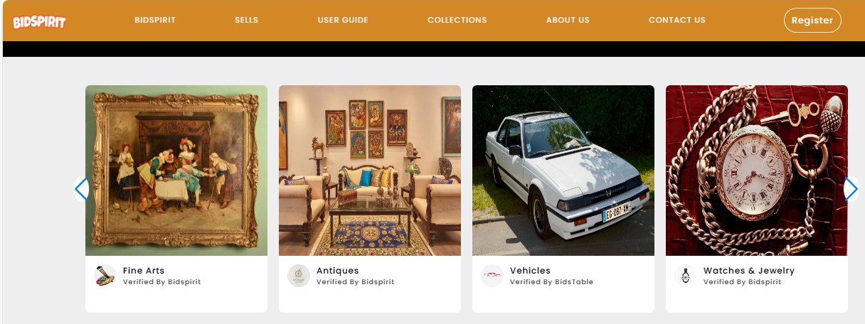

**Navbar:**



* There are seven essentials listed here, and you will be redirected to all the pages, which are further classified as:
* BIDSPIRIT
* SELLS
* HOW IT WORKS
* COLLECTION
* ABOUT US
* CONTACT US

**About Us:**

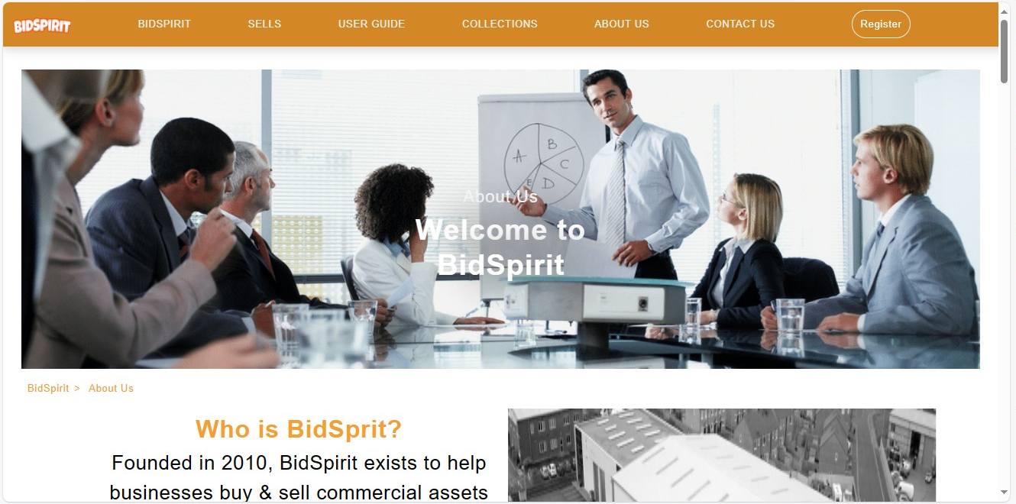

**Contact Us:**



**Footer:**



**Task Sheet Review:**

|  | | **Project Title** | **Date of Preparation of Activity Plan** | | | |
| --- | --- | --- | --- | --- | --- | --- |
| No. | **Task** |  | Actual | Actual | Name | Status |
| Start date | Days |
| 1 | Navbar & Footer | Auctions Table | 12/Sept/23 | 1 | Muhammad Taha | Complete |
| 2 | Build Home Page | Auctions Table | 13/Sept/23 | 2 | Abdullah kashif | Complete |
| 3 | Build Collections Page | Auctions Table | 18/Sept/23 | 5 | Muhammad Taha | Complete |
| 4 | Build About Us Page | Auctions Table | 21/Sept/23 | 3 | Rehan ahmed | Complete |
| 5 | Build Contact Us | Auctions Table | 23/Sept/23 | 2 | Muhammad Haseeb SHAHID | Complete |
| 6 | Build Auctions Page | Auctions Table | 25/Sept/23 | 1 | Muhammad Taha | Complete |
| 7 | Build Sells Page | Auctions Table | 26/Sept/23 | 1 | Muhammad Taha | Complete |
| 8 | Build How It Works Page | Auctions Table | 27/Sept/23 | 1 | Abdullah kashif and Muhammad taha | Complete |
| 9 | Build Sells Form Page | Auctions Table | 28/Sept/23 | 1 | Abdullah Kashif | Complete |
| 10 | Build Register Page | Auctions Table | 1/Oct/23 | 3 | Muhammad Taha | Complete |
| 11 | Build Auctions Sub-Pages | Auctions Table | 3/Oct/23 | 2 | Muhammad Taha | Complete |
| 12 | Build Collections Sub-Pages | Auctions Table | 7/Oct/23 | 4 | Muhammad Taha | Complete |
| 13 | Build Contact Us Form Page | Auctions Table | 9/Oct/23 | 2 | Muhammad Haseeb Shahid | Complete |
| 14 | Begin Code  JavaScript for all Pages | Auctions Table | 10/Oct/23 | 1 | Abdullah kashif & Muhammad Taha | Complete |
| 15 | Applying Animations on all over website | Auctions Table | 11/Oct/23 | 1 | Abdullah kashif | Complete |
| 16 | Make Documentation of all over website | Auctions Table | 11/Oct/23 | 1 | Muhammad Haseeb and Rehan ahmed | Complete |

**Summary:**

In collaboration with BidSpirit, the global frontrunner in fine art, antiques, furniture, and collectibles trading, our group is embarking on an exciting project to develop a state-of-the-art Single-Page-Application and responsive website. Our team, well-versed in technologies such as HTML5, JSON, Angular JS, JavaScript, and Geolocation, is enthusiastic about delivering a cutting-edge platform that will revolutionize the world of online auctions. The primary objective is to simplify the process of discovering and acquiring cherished items, making it more user-friendly and efficient than ever before. Furthermore, we're committed to ensuring cross-browser compatibility, so users can access the website seamlessly on Chrome, IE, Firefox, and other major browsers. This project represents a significant stride towards maximizing profitability for both sellers and buyers while eliminating the cumbersome paperwork traditionally associated with auctions. By bringing the entire auctioning process to the fingertips of users, we aim to usher in a new era of convenience and efficiency in the collectibles market. Our collective enthusiasm is geared towards making BidSpirit the industry's undisputed leader in the online marketplace.